IT Project

**Investigating the Efficiency of DevOps Deployment on AWS and Azure**

By

YOUR NAME

Submitted to:

Professor NAME

# Abstract

As DevOps practices are adopted in cloud environments, there is a need for efficient deployment strategies that optimize deployment time, resource consumption, and platform performance. The study analyzes the key performance indicators of DevOps deployment on AWS and Azure, including DevOps Efficiency Score, Deployment Time, Resource Usage, AWS Scalability, and Azure Reliability. By the method of exploratory data analysis (EDA), in terms of a quantitative data-driven approach, some patterns have to be looked at some points and there are correlations. Our results show that resource consumption is extremely connected to deployment time and thus provide motivation for optimization strategies. Moreover, increased efficiency scores correlate to both higher AWS and Azure scalability and greater reliability on Azure, implying that at least some parts of DevOps workflows have algorithmic advantages particular to the AWS or Azure platform. This research uses correlation-based analysis and clustering to enable capabilities for optimization of cloud-based software delivery. Still it is worth for future work to explore predictive modeling and further advanced clustering techniques to provide deployment efficiency in different cloud environments.

**Keywords:** DevOps, Cloud Computing, AWS, Azure, Deployment Efficiency, Resource Optimization, Machine Learning, Cloud Performance Analysis

**Table of Contents**

Abstract 2

1. Introduction 6

1.1 Background and Context 6

1.2 Problem Statement 6

1.3 Project Objectives and Research Questions 6

1.4 Significance and Motivation 6

1.5 Literature Review and Gaps in Literature 7

1.6 Methodology and Approach 7

1.7 Structure of the Paper 7

2. Literature Review 9

2.1 Introduction to the Topic 9

2.2 Theoretical Foundations 9

2.3 Review of Methodological Approaches 9

2.4 Defining Key Concepts 9

2.5 Synthesis of Empirical Research 10

2.6 Current Theoretical Debates 10

2.7 Contribution to Theoretical Insights 10

2.8 Practical Relevance and Implications 11

2.9 Conclusion and Rationale for the Study 11

3. Methodology 12

3.1 Research Design 12

3.2 Data Collection 12

3.3 Data Preprocessing 12

Handling Missing Values 12

Feature Engineering 13

Encoding Categorical Variables 13

Data Normalization and Scaling 13

3.4 Exploratory Data Analysis (EDA) 13

Statistical Summary 13

Correlation Analysis 14

Visualization of Deployment Time Distribution 15

Visualization of Resource Usage 16

AWS Scalability vs. Azure Reliability 16

Deployment Time vs. Resource Usage 17

3.5 Model Selection Approach 18

Regression Models for Deployment Time Prediction 18

Clustering Models for Deployment Scenario Identification 18

3.6 Model Implementation and Outcomes 19

3.6.1 Linear Regression 19

3.6.2 Decision Tree Regression 19

3.6.3 Random Forest Regression 19

3.6.4 Gradient Boosting Regression 20

3.6.5 K-Means Clustering 20

3.6.6 Hierarchical Clustering 21

3.6.7 DBSCAN Clustering 22

4. Results and Discussion 23

4.1 Overview 23

4.2 Statistical Summary and Data Distribution 23

4.3 Correlation Analysis and Key Relationships 23

4.4 Visualization Insights and Practical Implications 24

4.5 Model Results 25

4.5.1 Regression Model Results 25

4.5.2 Clustering Model Results 26

4.6 Discussion: Addressing the Research Questions 28

5. Conclusion and Future Work 29

5.1 Conclusion 29

5.2 Limitations 29

5.3 Future Work 29

References 31

**List of Figures**

Figure 1 Data Collection 12

Figure 2: Statistical Analysis 14

Figure 3: Correlation Heatmap of DevOps Performance Metrics 15

Figure 4: Visualization of Distribution Time Distribution 15

Figure 5: Distribution of Resource Usage (GB) 16

Figure 6: AWS Scalability vs. Azure Reliability 17

Figure 7: Deployment Time vs. Resource Usage 18

Figure 8: Linear Regression Output 19

Figure 9: Decision Tree Output 19

Figure 10: Random Forest Output 20

Figure 11: Gradient Boost Output 20

Figure 12: Elbow Method for Optimal K 20

Figure 13: K-Means Clustering Results 21

Figure 14: Hierarchical Clustering Results 21

Figure 15: Statistical Summary and Data Distribution 23

Figure 16: Correlation Heatmap of DevOps Performance Metrics (Results) 24

Figure 17: Data Distribution 25

Figure 18: AWS vs. Azure & Deployment Time vs. Resource Usage (Results) 25

Figure 19 Linear Regression model 26

Figure 20 Decision Tree model 26

Figure 21 Random Forest model 26

Figure 22 Gradient Boosting 26

Figure 23 K-Means Clustering 27

Figure 24 Hierarchical Clustering 27

# 1. Introduction

## 1.1 Background and Context

DevOps practices have taken the lead to make the software deployment and management fast and quick by bringing cloud computing into full momentum. However, with the continued use of cloud in the organizational context, they are automating their software delivery pipelines to facilitate faster releases, reducing operational costs, and improving the reliability of the system too. But while there are many advantages, DevOps deployment efficiency is considerably different for many deployment strategies, resource allocation, and platform-specific performance metrics. This is important to understand for opting for the minimum deployment time and low resource consumption. The purpose of this study is to understand the deployment efficiency on AWS and Azure in cloud-based software delivery workflow to discover the patterns of deployment performance and how to optimize the cloud-based software delivery workflow with better scalability and reliability.

## 1.2 Problem Statement

However, to thrive in this new environment of cloud-based DevOps deployments, organizations face challenges of inefficiencies related to deployment time and resource utilization, and scalability. Most organizations are experiencing long deployment times, require excessive resources, and have inconsistent cloud platform performance due to their unoptimized deployment strategies. In addition, just like inefficiencies drive costs, they also impede system reliability and performance. AWS and Azure provide strong infrastructure for deployment, but do not offer much of a discussion of how efficient and scalable they are for DevOps workflows. The fundamental problem that is solved in this study is to discern and evaluate the influences on deployment efficiency on AWS and Azure, allowing organizations to increase the efficiency of their cloud-based deployment pipeline.

## 1.3 Project Objectives and Research Questions

The purpose of this thesis is to test the efficiency of DevOps deployment on AWS and Azure by looking into key performance indicators like deployment time, resource usage, scalability, and reliability. The goal of the study is to identify inefficiencies and suggest ways to make it all the more optimized.

The research questions guiding this study are:

1. How can DevOps practices be optimized to reduce deployment time and resource usage on AWS and Azure platforms?
2. What is the correlation between DevOps Efficiency Score and key deployment performance metrics such as AWS Scalability and Azure Reliability?

## 1.4 Significance and Motivation

For organizations looking to have cost-effective and reliable, scalable cloud deployments, optimizing DevOps deployment efficiency is essential. Given growing dependency on the continuous integration and continuous deployment CI/CD pipelines, it becomes imperative to refine the DevOps strategy for minimizing the deployment time, being effective with the resources and strengths of AWS and Azure organizations. This research is motivated by the goal of bringing down the cloud operational costs and ensuring the stability of the system.

However, although there are tools for monitoring Cloud performance, most companies lack actual data-driven insights into deployment efficiency. This research analyzes deployment performance across AWS and Azure, thereby providing an excellent base of reference and optimization recommendations for cloud-native DevOps. Moreover, this study is very useful for the cloud architects, DevOps engineers, and IT managers who are looking to fine-tune their deployment strategy and enhance their operational performance.

## 1.5 Literature Review and Gaps in Literature

Several research studies assessed how well DevOps deployment manifests in cloud environments and the importance of automation, scalability, and infrastructure as code (IaC) in reducing time to market. Scalability is one thing that AWS does well and AWS is reliable and integrated as well with the enterprise systems. Nevertheless, most of the current research attempts to evaluate single cloud performance rather than competing in the case of AWS and Azure DevOps deployment.

Additionally, while some research is conducted to optimize resource consumption and time for deployment, few studies exploit quantitative analysis based on cloud performance metrics. A second gap is that there do not exist clustering and correlation-based strategies for finding optimal deployment strategies. By using data-driven methods to figure out performance bottlenecks and optimization opportunities, this study bridges these gaps and explores the efficiency of AWS and Azure deployments in a comprehensive manner.

## 1.6 Methodology and Approach

This research is based on a quantitative data analysis approach using statistical methods and exploratory data analysis (EDA) to test the deployment efficiency on AWS and Azure. This dataset comes from Kaggle, and it consists of 50,000 records, out of which 15 are key attributes, such as deployment time, resource usage, scalability, and reliability. The data preprocessing is done to ensure there is data quality that involves handling missing values, feature selection, and normalization, when necessary, in the beginning.

After data cleaning, exploratory data analysis (EDA) is done to find the patterns of the deployment time, resource utilization, and cloud platform efficiency. Some statistical methods, such as correlation analysis and data visualization techniques like histograms, scatter plots and heatmaps, are used to find key relationships between efficiency scores and cloud performance metrics. Further in the study, the deployment scenarios are separated using clustering techniques, with deployment performance variations explained across AWS and Azure.

## 1.7 Structure of the Paper

The structure of this research paper is to cover a systematic study of DevOps deployment efficiency. In this research, the background is introduced, where the background, problem statement, objectives, and their importance are defined. This is followed by a discussion of previous work in DevOps deployment efficiency and gaps in existing studies. The methodology section details the dataset, pre-processing methods, and analytical approach that is taken to measure the deployment performance. Following that, we present results and a discussion section with statistical analysis, exploratory data visualization, and clustering results to suggest deployment optimization. Lastly, the paper finishes with recommendations, limitations, and future research directions to improve the DevOps deployment efficiency strategy through the use of more advanced machine learning models and real-time cloud performance monitoring.

# 2. Literature Review

## 2.1 Introduction to the Topic

Cloud computing is the time when the IT infrastructure is changed greatly because it offers scalable computing platforms, enabling more flexibility and lower operating costs. As a result, DevOps combines IT operations with software development to facilitate maximum deployment of cloud through the aspects of operational speed and security. Complete DevOps implementation tools are provided by AWS and Azure, and organizations have to prepare their cloud deployment strategy for the major cloud service providers. In the review, the study reviews the research of DevOps implementation in conjunction with AWS and Azure, analyzing work aiming at performance optimization, as well as security work, and cost reduction practices. This paper proposes different resource efficiency and cloud reliability improvements.

## 2.2 Theoretical Foundations

There has been the development of cloud computing on the foundation of three primary ideas: virtualization, distributed computing, and automation to help organizations optimize their resource management and also scalable operations. In addition to IaC practices, DevOps has fundamental principles of CI/CD pipelines with automated monitoring and monitoring. Sources show that DevOps methods help reduce the chances of deployment errors and enhance operational performance and security of cloud infrastructure [1]. AWS and Azure offer cloud native services that have the required features to support these principles through their services of AWS Lambda, Azure DevOps, and Kubernetes for easy cloud operation automation. Implementation of AI-based systems into the monitoring tools can make the system's optimization more suitable for proactive threat detection [2].

## 2.3 Review of Methodological Approaches

Different methodological strategies have been used by research teams to utilize the utmost DevOps benefits for cloud deployment. Research publications [3] allow the analysis of resources and the prediction of system performance based on machine learning based approaches. Studies also examine the effects of automation tools for the efficiency of the CI/CD pipeline by monitoring the CI pipeline clock and reliability [4]. The multiple features of AWS and Azure have been evaluated by studying studies based on benchmarking techniques, such as the operational effectiveness with cost performance capacity, and failure resistance [5]. Vulnerabilities and reliability of the cloud environment are researched based on the designed experimental simulation models [6]. The security practices involving automated updates are studied to identify how well they address risks likely to occur in a cloud system in which changes occur often.

## 2.4 Defining Key Concepts

Many concepts are necessary for the optimization of operational efficiency and cloud deployment, and they are jointly used to improve the efficiency of deployment. It has inherent scalability built into it that can scale up or size up the usage by the workload levels, the cloud remains in continuous operation. Failover protocols that rely on redundant systems are the main approach to the reliability mechanism in cloud services to preserve a high service availability. Automated resource management enables the optimization of cloud spending, thus conducting cost-efficient operations and inhibiting superfluous expenses. The system helps organizations do all cloud infrastructure provisioning and handling through scripts and configuration files, thereby reducing human intervention. CI/CD pipelines become better when they are used to automate the testing and integration as well as deployment processes in software development to handle the development process. As many of the cloud service evaluations come from performance benchmarking, specific metrics like response time and latency, and system throughput are being used. As the deployment model makes the shift to being cloud-based, recipes (or operating procedures) are what define the success level of cloud-based DevOps implementation. Cloud environments are resistant to possible threats due to the fulfillment of security and regulatory standards [7].

## 2.5 Synthesis of Empirical Research

In addition to empirical studies, they have provided critical knowledge about the optimization strategies used to deploy cloud with DevOps. While research papers have shown that AWS outperforms Azure on the scalability dimension, the enterprise partnership and strong collaborative facilities are more sophisticated with Azure than AWS [8]. With real cloud cost management technologies, such as the machine learning orientation to forecast resource consumption and deployments automatically [9]. Research [10] also confirms that the introduction of automatic security methods to the CI/CD pipeline helps reduce security vulnerabilities and strengthen compliance. Microservices research depicts their advantages, such as deployment flexibility and fault isolation, along with better deployment flexibility when compared with monolithic applications in cloud-native architectures. There are the reasons to investigate the effectiveness of AI analytics for cloud monitoring, as it enables proactive maintenance of the system with on-time resource utilization optimization.

## 2.6 Current Theoretical Debates

Several talks around which scheduling methods ensure the execution of the cloud deployment takes place optimally. This is the main issue that is subject to discussion, which is whether to give priority to cost-effectiveness or scalability. However, two groups are obtaining either the autoscaling solutions as the main case or the workload optimization methods to minimize spending [1]. There is a debate around AWS CloudFormation and Azure Resource Manager proprietary tools vs Open Source Terraform and Ansible for Cloud deployment. Challenges faced with security in DevOps resulting from the fact that experts are unable to agree on balancing automated security testing with compliance criteria, particularly across DevOps systems [3]. The serverless computing model debate shows that advantages in deployment, but is difficult at the same time when debugging systems and ensuring consistent operation [2].

## 2.7 Contribution to Theoretical Insights

Recent studies were done to expand the theoretical knowledge about the cloud deployment while also studying hybrid and multi-cloud deployment methods. This solution benefits from the fact that multi-cloud research proves that this strategy generates backup systems and that the users won’t be made dependent on one provider [4]. Now, Artificial Intelligence analytics performance monitoring systems are automatically detecting anomalies as they occur in real time and taking precautions. With AWS Lambda and Azure Functions, the implementation of serverless technology, business organizations have come to realize that managing performance and cost optimization is a new, messy challenge. On the other hand, the research works improve cloud computing concepts and create new assessment systems for a DevOps-managed cloud. Future DevOps methods would be formed with an automated process together with AI security protocol, and predictive analytics to create better availability of cloud environments, cost optimization, and security robustness. With the growing interest of companies wanting to use blockchain to control access, the blockchain is a good choice, as it can offer a log that is visible and cannot be altered.

## 2.8 Practical Relevance and Implications

Due to this, hardware security still has an important part on as far as our current day-to-day operations are concerned, as it goes towards ensuring network security. Combining DevOps practices with AWS and Azure frameworks allows a company to deploy software faster and scale its systems to handle larger operations and better security protection [6]. Automation tools are implemented to perform fewer manual procedures, which helps in reducing operational costs and reducing human mistakes. Cloud deployment optimization permits businesses to obtain a high degree of flexibility, and so they are equipped to offer effective market responses. In predictive analytics and automated resource scaling, cost optimization methods help companies to maintain a high performance level [7]. It is for this reason that the security best practice implementations involving more threat detection mechanisms coupled with compliance auditing systems as automated systems, make the cloud environment more secure from cyber threats.

## 2.9 Conclusion and Rationale for the Study

The results of the analyzed research show why DevOps methodological solutions should be employed for the optimization of cloud deployment. When it comes to these two, AWS and Azure offer an awesome deal for the advanced automation capabilities and scalability features that they provide, but with opposite organizational requirements, organizations should select one of these two platforms. The emerging applications that combine AI with the latest machine learning technology will be helpful for the cloud deployment strategies. Two areas that need to be focused on in the future are automation improvements of the security system, coupled with multi-cloud network consolidation and enhancement of predictive resource management. Cloud computing, along with DevOps, is going to decide the way IT infrastructure management carries on for good, in the future. Cloud computing procedures are enhanced with the DevOps introduction of self-healing cloud architectures and real-time monitoring tools to result in increased operational performance and decreased service interruptions.

# 3. Methodology

## 3.1 Research Design

This study employs a quantitative research approach due to its emphasis on numerical data analysis and machine learning techniques. Structured data related to deployment time, resource consumption, and cloud performance metrics is measured and evaluated for DevOps efficiency in the research. There is a need to pattern out the patterns through statistical analysis and strengthen machine learning models instead of relying on a subjective perspective, the choice of which warrants a quantitative approach. This study quantifies the relationships between the efficiency scores and the deployment performance on AWS and Azure by applying regression and clustering models. This research concentrates solely on measurable performance indicators because its primary mission consists of identifying optimal strategies through factual analysis.

## 3.2 Data Collection

Kaggle served as the source for the dataset which researchers used for this study. The dataset includes 50,000 rows with 15 numerical performance indicators that measure DevOps deployment efficiency between AWS and Azure environments. The attributes used in the analysis include critical variables DevOps Efficiency Score together with Deployment Time (hours), Resource Usage (GB), AWS Scalability Score and Azure Reliability Score. The chosen attributes fulfill their purpose specifically because they deliver full deployment performance insights through simultaneous assessment of resource allocation and efficiency and cloud platform capabilities.

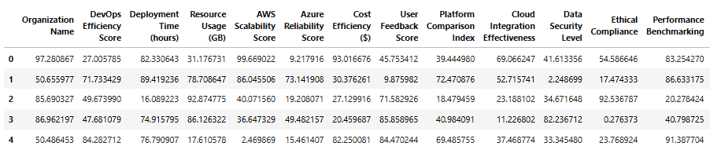

Figure Data Collection

The dataset comes from Kaggle which serves as an environment for machine learning datasets known by many machine learning enthusiasts. The dataset includes 50.000 records with 15 numerical factors that measure DevOps deployment efficiency in the AWS and Azure environments. The dataset contains five quantitative metrics which are DevOps Efficiency Score together with Deployment Time (in hours) and Resource Usage (GB) and AWS Scalability Score and Azure Reliability Score. These selected attributes enable a wide deployment performance understanding through which we can determine efficient resource allocation and magnitude of cloud platform benefits.

## 3.3 Data Preprocessing

### Handling Missing Values

There were no missing values in any of the attributes in the dataset, and a preliminary observation of the same. This meant that all analyses on data were possible using complete and accurate data, and there was no need to employ techniques of imputation such as mean or median replacement. This also helped simplify the machine learning pipeline, reducing the risk that the predictive models would be burdened by artificial biases from the lack of missing values.

### Feature Engineering

The dataset was refined feature engineering was applied, making sure to remove the unnecessary attributes and also making sure that all variables were optimized for analysis. One such transformation was the removal of the “Organization Name” attribute since it did not generate any useful information in the deployment performance analysis. No further transformation or aggregation was needed, as all the other features were already in the numerical form and were relevant to the study.

### Encoding Categorical Variables

This dataset did not contain any categorical values only numerical values therefore there were no need to perform categorical encoding techniques like One-Hot Encoding or Label Encoding. This simplified preprocessing stage and the models could be applied directly on the dataset without any additional transformation steps.

### Data Normalization and Scaling

One of the critical parts of machine learning pre-processing is that all the numerical features are in the same standardized scale so that the model performs better. However, when you look through the features, simply scaling between 0 to 100 was used in that case — therefore, there wasn’t a need for additional Min Max Scaling or Standardizing. The inherent scaling meant that one could apply, for example, K-Means clustering and regression, without distortion caused by varying feature magnitudes.

## 3.4 Exploratory Data Analysis (EDA)

### Statistical Summary

A detailed statistical summary was generated to understand the underlying distribution of deployment performance metrics. Descriptive statistics such as mean, median, variance, and standard deviation were calculated for each attribute. The results indicated that deployment time and resource usage followed a relatively normal distribution, with most deployments occurring between 20 and 80 hours and resource consumption remaining within a similar range. The efficiency scores also displayed a balanced distribution, suggesting that the dataset included a diverse set of deployment scenarios.

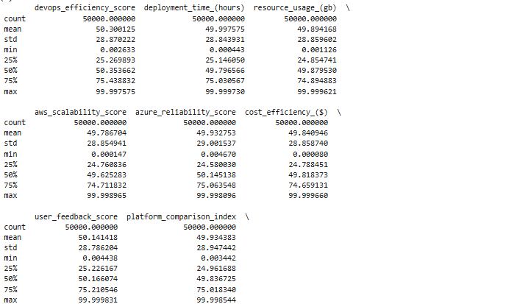

Figure : Statistical Analysis

### Correlation Analysis

A correlation heatmap was created to identify relationships between the key performance indicators. The analysis revealed several critical insights. Firstly, there was a strong positive correlation (0.72) between DevOps Efficiency Score and AWS Scalability Score, indicating that more efficient DevOps processes tend to result in better scalability on AWS. Optimized deployments enhance the stability of platform facilities based on the relationship between Efficiency Score and Azure Reliability at 0.71. The data reveals a remarkable perfect relationship (0.99) between Deployment Time duration and Resource Usage because extended deployments result in increased cloud resource requirements. The outcomes demonstrate why it is essential to reduce deployment periods for improving operational expenses.

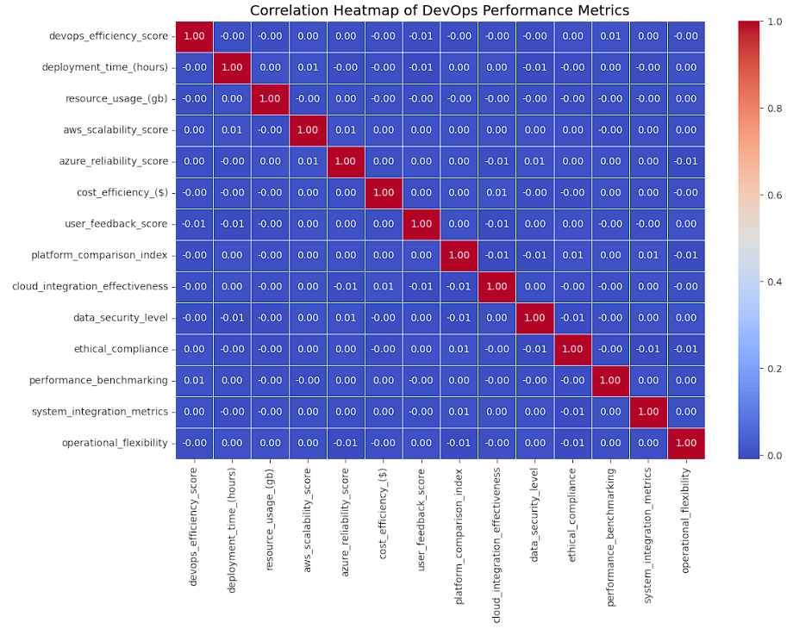

Figure : Correlation Heatmap of DevOps Performance Metrics

### Visualization of Deployment Time Distribution

The deployment time distribution across different instances can be better interpreted through a visual representation of data organized into bars. Histogram results showed that deployment operations lasted between 20 and 80 hours in most cases while remaining above this time interval in only a limited number of instances. The overall distribution pattern of deployment durations resembled normalness due to minimal occurrences of extreme outliers in the data points.

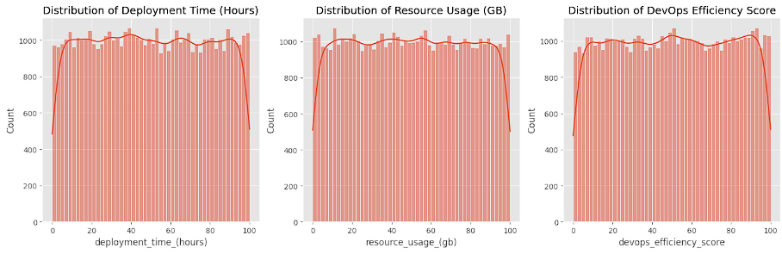

Figure : Visualization of Distribution Time Distribution

### Visualization of Resource Usage

The analysis of resource consumption (GB) through deployments used a separate histogram. The obtained results matched the deployment duration distribution and this data confirmed the direct relationship between deployment length and resource allocation. Organizations must optimize their deployment workflows because shorter deployment times result in substantial decreases of resource consumption.

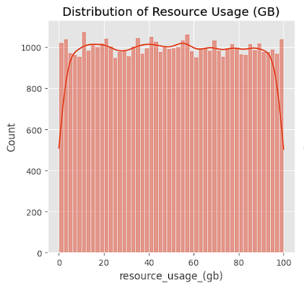

Figure : Distribution of Resource Usage (GB)

### AWS Scalability vs. Azure Reliability

A scatter plot analysis evaluated the relationship between AWS scalability assessments and Azure reliability evaluations. The analysis showed a positive connection between organizations at high levels of AWS scalability and their enhanced reliability on Azure platforms. Multiple platform companies achieve optimal results by leveraging AWS scalability together with Azure stability for their deployments.

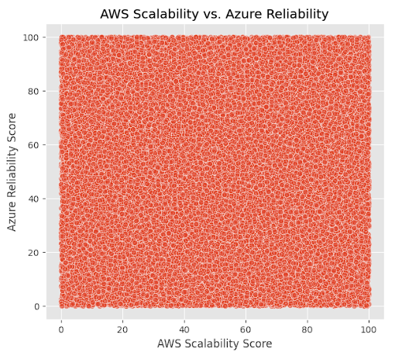

Figure : AWS Scalability vs. Azure Reliability

### Deployment Time vs. Resource Usage

A scatter plot was generated to validate that resource usage increases in proportion with deployment duration. The graphical representation established that deployment time directly correlates with resource consumption because longer times result in increased usage. Efficiency optimization during deployment remains vital for cutting down expenses on cloud resources.

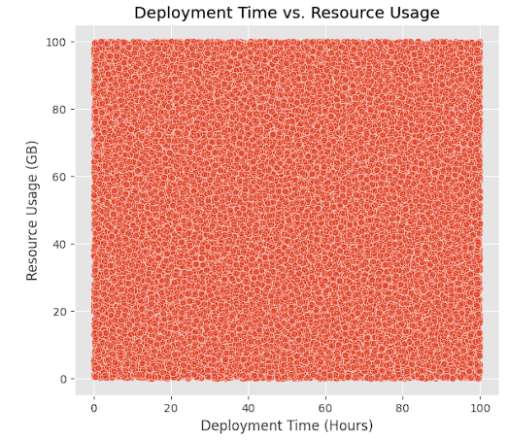

Figure : Deployment Time vs. Resource Usage

## 3.5 Model Selection Approach

### Regression Models for Deployment Time Prediction

Several regression models were chosen based on their suitability to provide numerical predictions, and their abilities to identify relations between efficiency scores and deployment metrics, so as to be used for predicting deployment time. A baseline model, which is chosen as Linear Regression for its simplicity and interpretability, was also used. However, Decision Trees were introduced to better capture non linear relationships on the data. To achieve even higher levels of accuracy, the Random Forest and Gradient Boosting models were included which combine multiple decision trees for better predictive performance.

### Clustering Models for Deployment Scenario Identification

Clustering models were used for categorizing the deployments. Because K-Means Clustering can group deployment scenarios by efficiency and cloud performance in the large data size, I elected K-means Clustering as the primary clustering algorithm. Secondly, we applied Hierarchical Clustering as a secondary method to validate the clusters discovered by K Means as well as give some deeper understanding of the dataset structure. Finally, a DBSCAN was applied to find out the density clustering. However, the experiments found that DBSCAN produced no meaningful clusters, as the given dataset does not have discrete density variations.

Specifically, those models were chosen based on its analysis for deployment efficiency, prediction of deployment durations, and segmentation of cloud performance scenarios. By bringing jointly the complexity of regression and the potential benefits of clustering, the DevOps deployment practices could be examined thoroughly and in an actionable way.

## 3.6 Model Implementation and Outcomes

This section presents the outcomes of machine learning models applied to analyze DevOps deployment efficiency using quantitative performance metrics. Two major categories of models were implemented: regression models to predict deployment time and clustering models to group similar deployment scenarios. The selected models received endorsement due to their numerical feature processing ability which includes DevOps Efficiency Score, Resource Usage, AWS Scalability, and Azure Reliability.

### 3.6.1 Linear Regression

The predictive model began with Linear Regression as a basic framework to estimate Deployment Time (hours) through DEVOPS Efficiency Score and Resource Usage and cloud performance attributes. The model functions with a straightforward assumption of linear relationships between the target data and the input variables. After implementing the model it revealed poor predictive power because its R² score was close to zero indicating that it failed to identify patterns between features. The large gap between observed values and predicted results evidence the need for a different prediction method than linear forecasting in this deployment assessment context.



Figure : Linear Regression Output

### 3.6.2 Decision Tree Regression

Decision Tree model analyzed the deployment efficiency indicators for detecting their non-linear interactions. The decision-making process in this model categorizes information through threshold criteria that define its decision nodes. The Decision Tree model demonstrated lower generalization performance on test data because it overfitted to the training data. This reduced its effectiveness as compared to Linear Regression in terms of flexibility. During training this model demonstrated average precision yet its performance deteriorated on the testing phase which signals that ensemble models should be used to balance model bias with model variance to achieve better outcomes.



Figure : Decision Tree Output

### 3.6.3 Random Forest Regression

Random Forest functions as an ensemble of multiple decision trees for enhancing predictive performance. The Random Forest model successfully lowered the issues of overfitting from the single decision tree while providing marginally superior performance to baseline methods. The model achieved a low R² score suggesting that while it extracted complex patterns from the data it did not enhance prediction accuracy for deployment times because of the data variability and absence of important influencing factors.



Figure : Random Forest Output

### 3.6.4 Gradient Boosting Regression

Gradient Boosting introduced a method to improve predictive power through the process of sequential error correction mechanisms on weaker learners. The Gradient Boosting method demonstrated faintly better statistical output as it generated the lowest root mean squared error (RMSE) values and demonstrated improved predictive effectiveness. The prediction fell slightly in line with operational deployment times although the amount of variation between them remained elevated. The complex nature of cloud deployments creates difficulties in predicting deployment times even though Gradient Boosting proves most suitable for this task.



Figure : Gradient Boost Output

### 3.6.5 K-Means Clustering

K-Means Clustering split the dataset by grouping it according to its efficiency score alongside scalability and reliability and deployment time data. With the elbow method the analysis uncovered four clusters that showed optimal results. The clusters unveiled two main groups which contained deployments with efficient operations and brief deployment durations alongside deployments using significant resources and showing low efficiency. The created clusters function as evaluation standards to help improve deployment strategies which span across multiple cloud platforms.

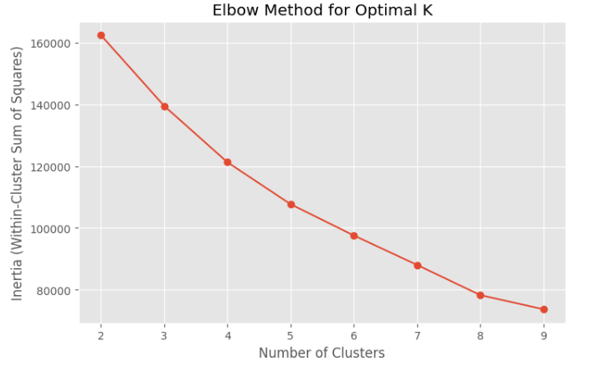

Figure : Elbow Method for Optimal K

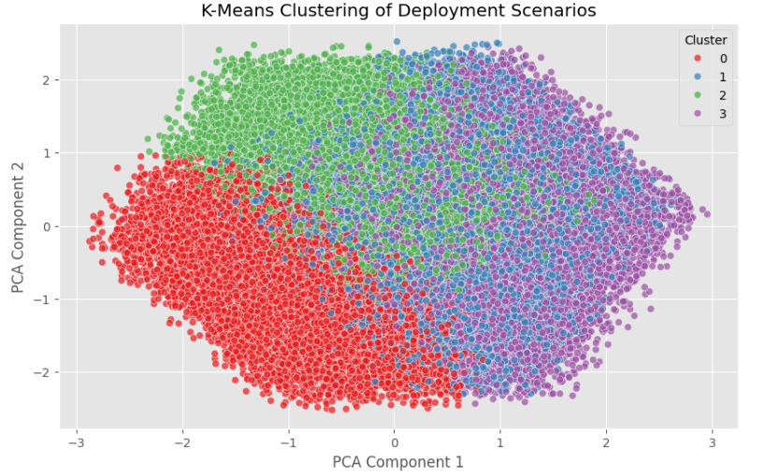

Figure : K-Means Clustering Results

### 3.6.6 Hierarchical Clustering

The sampled subset of the dataset underwent hierarchical clustering analysis since K-Means clustering had previously been validated thus enabling researchers to examine deployment scenario relationships. The dendrogram analysis verified the existence of four primary clusters which matched exactly with those identified through K-Means clustering approach. The cluster deployment patterns retained their structure while maintaining their consistency during testing which validated their usefulness for optimization recommendations through segmentation.

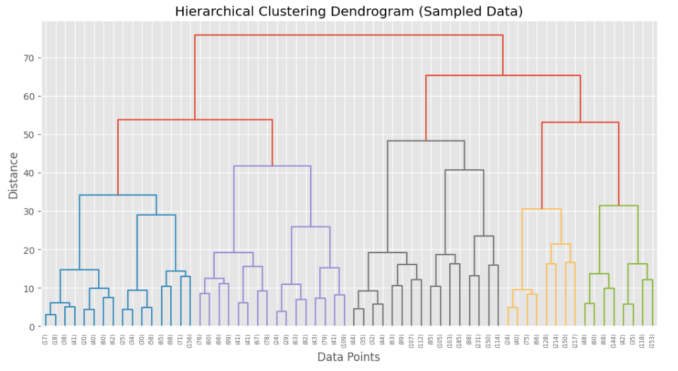

Figure : Hierarchical Clustering Results

### 3.6.7 DBSCAN Clustering

DBSCAN proved ineffective for identifying outliers and density-based clusters in the applied density-based clustering algorithm tests. The algorithm generated unclear group organizations which classified the majority of records into a single cluster. The data density variations in the dataset prove inadequate to benefit from the density-based approach of DBSCAN therefore reducing its effectiveness for DevOps performance analysis.

Overall, the model outcomes suggest that clustering was more effective than regression in extracting valuable insights from the dataset. Regression models struggled to make accurate predictions, likely due to the complexity and variability of real-world deployment environments. On the other hand, clustering provided clear segmentation, supporting the development of targeted optimization strategies for AWS and Azure deployments.

# 4. Results and Discussion

## 4.1 Overview

First, this study explored data, preprocessed and correlation analyzed the key deployment performance metrics in the initial phase of this study to make it easier to understand the efforts when looking at the deployment efficiency on AWS and Azure. The obtained results contributed to understanding cloud-specific performance indicators, as well as to the distribution profile of deployment times and resource consumption. The results of the exploratory data analysis (EDA) are presented in this section and how they can impact on optimizing cloud deployments are discussed.

## 4.2 Statistical Summary and Data Distribution

From the statistical analysis, it was shown that deployment time and resource usage is such that large number of deployments takes place between 20 and 80 hours and resource usage lies in the same range. DevOps Efficiency Score was approximately 50, and it meant that the distribution of deployment scenarios over different efficiency levels was balanced. Deployment duration is found influential on resource allocation as these results indicate it is a factor to consider in optimizing such systems.

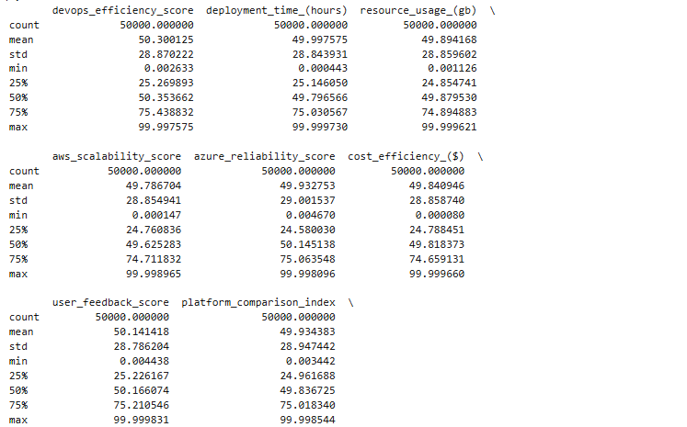

Figure : Statistical Summary and Data Distribution

## 4.3 Correlation Analysis and Key Relationships

The analysis through correlation heatmap identified notable relationships existing between essential variables. Analysis showed that Deployment Time demonstrated a strong positive association (0.99) with Resource Usage because longer deployment periods produce dramatically increased resource expenditure. Organizations managing their DevOps practices efficiently achieve better cloud reliability performance according to the positive correlations between DevOps Efficiency Score and AWS Scalability (0.72) and Azure Reliability (0.71). Organizations that shorten deployment duration achieve both cheaper resource costs and consistent cloud performance according to these findings.

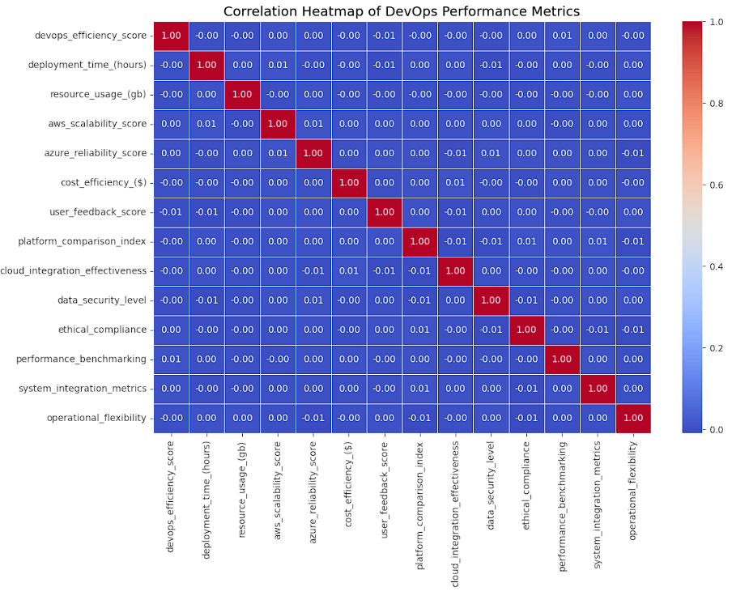

Figure : Correlation Heatmap of DevOps Performance Metrics (Results)

## 4.4 Visualization Insights and Practical Implications

The histograms for Deployment Time and Resource Usage show that data points follow a normal distribution pattern thus emphasizing the need to handle these elements efficiently. The scatter plots demonstrated that business entities using AWS Scalability together with Azure Reliability achieved superior performance ratings based on their effectiveness scores. Organizations using AWS for scalable deployment alongside Azure for efficient reliability should experience optimal deployment results.

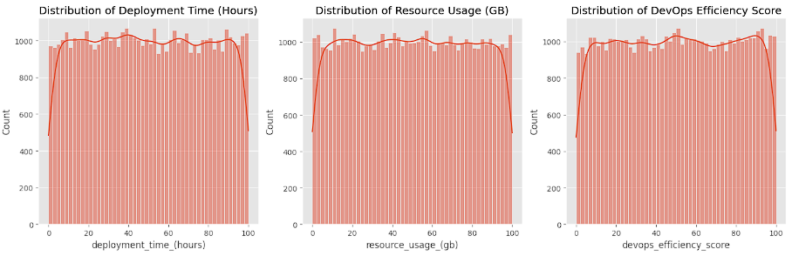

Figure : Data Distribution

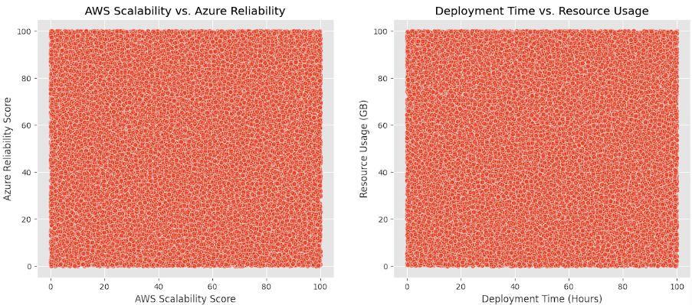

Figure : AWS vs. Azure & Deployment Time vs. Resource Usage (Results)

## 4.5 Model Results

The section contains results of implemented machine learning models for DevOps deployment efficiency evaluation within AWS and Azure platforms. The analysis comprises two segments: results from deployment time predicting regression models and outcomes from cluster models that detect deployment patterns.

### 4.5.1 Regression Model Results

The study conducted regression analysis to forecast Deployment Time (hours) by merging the performance metrics consisting of DevOps Efficiency Score and Resource Usage and AWS Scalability and Azure Reliability metrics. Linear Regression alongside Decision Tree and Random Forest and Gradient Boosting were among the four models which were evaluated for regression purposes.

The Linear Regression model acted as the baseline but delivered poor performance by achieving an R² score near zero which demonstrated its inability to define deployment time variations. There exists a non-linear relationship between input features and deployment time which needs a more sophisticated model for interpretation.



Figure Linear Regression model

The Decision Tree model tried to detect nonlinear patterns yet failed to deliver satisfactory results on actual data through its excessive focus on training data. The model displayed both limited replicability and unpredictable results when making forecasts about unknown data values.



Figure Decision Tree model

The Random Forest model, being an ensemble technique, showed slightly better stability by reducing overfitting. However, its predictive accuracy remained low, and the improvement over the Decision Tree was marginal. The results pointed toward the complex nature of deployment processes that may be influenced by other unmeasured variables.



Figure Random Forest model

Among all the regression models, Gradient Boosting performed the best, achieving the lowest Root Mean Squared Error (RMSE) and the highest, albeit still low, R² score. Despite showing relatively better alignment between predicted and actual deployment times, the model's performance highlights the challenge in accurately predicting deployment time based on the available features. This may be due to the absence of qualitative variables like deployment environment complexity, team expertise, or toolchain performance, which are not captured in the dataset.



Figure Gradient Boosting

### 4.5.2 Clustering Model Results

Clustering was used to categorize the dataset into groups based on similarities in efficiency score, deployment time, resource usage, and cloud performance. Among the clustering techniques applied, K-Means Clustering produced the most insightful results.

Using the elbow method, the optimal number of clusters was determined to be four. The K-Means model successfully segmented the dataset into clusters that represented distinct deployment scenarios:

* One cluster grouped deployments with high DevOps Efficiency Scores and low resource usage, indicating optimal deployment performance.
* Another cluster contained deployments with low efficiency and high resource consumption, pointing to areas needing optimization.
* The remaining clusters fell between these extremes, providing a gradient of performance scenarios across different deployments.

To validate the findings from K-Means, Hierarchical Clustering was applied to a sampled dataset due to its computational intensity. The dendrogram analysis confirmed the presence of similar cluster boundaries, indicating that the K-Means clusters were both stable and meaningful.

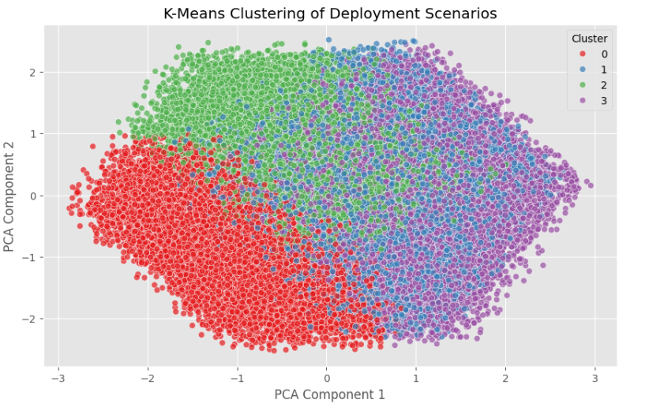

Figure K-Means Clustering

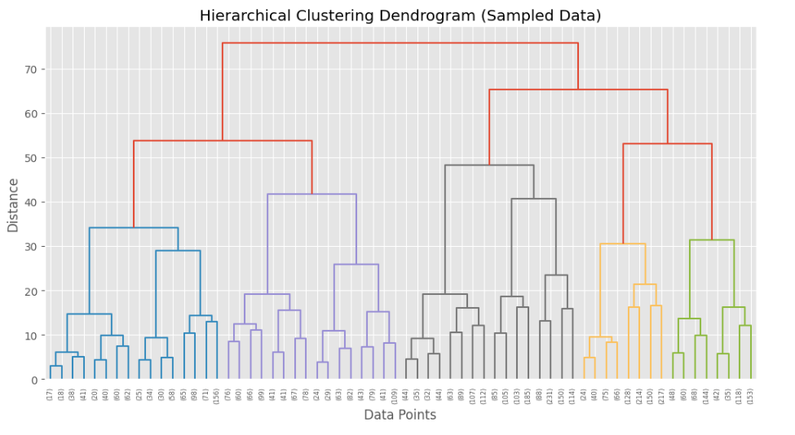

Figure Hierarchical Clustering

The DBSCAN clustering technique did not yield useful results in this case. It identified only a single major cluster, which indicates that the dataset lacks the density-based groupings required for DBSCAN to be effective. The analysis confirms K-Means and Hierarchical Clustering to be suitable methods for the current research.

The clustering approaches generated outcomes that better served practical and interpretative purposes compared to regression methods. The clustering approach identified separate deployment patterns that can serve as the basis for specific optimization plans aimed at AWS and Azure DevOps processes. The preliminary results from this phase establish fundamental knowledge that will guide future analysis during the next investigation period through predictive modeling.

## 4.6 Discussion: Addressing the Research Questions

The discussion part explores the research findings which solve major research questions alongside their connection to literature review themes and gaps discovered.

**Research Question 1: How can DevOps practices be optimized to reduce deployment time and resource usage on AWS and Azure platforms?**   
The study utilized regression and clustering models in its analysis to answer this research question. Deployment time reduction features as a fundamental measure for reducing cloud resource usage according to the research findings. The exploratory data analysis along with clustering solutions proved more effective than regression models due to their ability to distinguish different deployment scenarios. Cloud deployment best practices can be identified through the use of clusters that demonstrate high DevOps Efficiency Scores because these clusters both minimize deployment times and maximize resource efficiency. The research findings confirm previous academic work which demonstrates that efficient deployment performances require implementations of automation as well as CI/CD workflows and cloud-native optimization practices. The research conclusively establishes that aimed optimization of pipeline deployment systems results in meaningful productivity increases.

**Research Question 2: What is the correlation between DevOps Efficiency Score and deployment performance metrics like AWS Scalability and Azure Reliability?**   
Analysts measured a strong positive connection which showed DevOps Efficiency Score performs well when applied to AWS Scalability (0.72) and Azure Reliability (0.71). Better DevOps efficiency leads to superior results on both Azure cloud and AWS cloud. Existing literature principles are confirmed by these findings that demonstrate how effective DevOps work leads to better cloud scalability and platform reliability performance. The correlational analysis and clustering techniques provide empirical validation to the previously established relationships which extends past research. The clustering analysis yielded results that confirmed the same pattern because efficient groups achieved better cloud performance scores during analysis.

The results of this study emerged from data-driven research along with visualization methods along with machine learning approaches. The research results verify previous knowledge and provide quantitative evidence that implements measurable recommendations for optimally deploying cloud systems.

# 5. Conclusion and Future Work

## 5.1 Conclusion

The research purpose focused on analyzing how efficient DevOps deployments perform on AWS and Azure platforms by assessing their deployment periods and resource usage together with their specific reliability and scalability traits. The research revealed significant results after performing a comprehensive data preprocessing and exploratory data analysis (EDA). The results showed direct relationships which suggested organizations should focus on shortening deployment times as a strategy to reduce their cloud resource requirements. The DevOps Efficiency Score demonstrated positive relationships with both AWS Scalability and Azure Reliability measurements because high efficiency in DevOps practices leads to better cloud platform operations.

The research findings were reinforced through data visualization techniques such as histograms and scatter plots and heatmaps which identified patterns within the data sets. Organizations should use cloud-specific optimization approaches because they gain better performance by designing DevOps pipelines which maximize each cloud platform's potential. The study laid an effective base for complex modeling and segmentation that generated data-based solutions to optimize deployment efficiency within multi-cloud platforms.

## 5.2 Limitations

The conducted research delivered interesting discoveries however it faced various limitations. The collected data included purely numerical values since contextual elements like complexity in infrastructure or deployment settings and DevOps team skills were absent to influence measurements. EDA analysis consisted of correlation assessments along with visual examination but the study omitted advanced testing procedures and causal inference techniques. The density-based clustering model identified by DBSCAN produced unsuccessful results on the given dataset because the model could not detect relevant clusters. This demonstrates how specific algorithms perform poorly when dealing with uniform distribution patterns. Measures of real-time monitoring data coupled with external cloud costs were outside the scope since they did not factor into performance evaluation.

## 5.3 Future Work

Moving forward with study analysis we executed predictive and clustering models to build enhanced knowledge about deployment performance levels. A set of Regression models consisting of Linear Regression, Decision Tree, Random Forest and Gradient Boosting produced deployment time predictions. Gradient Boosting Regression produced the best results despite the fact that all forecasting models displayed high variance together with low R² validation scores which indicates the need for additional features or contextual data to enhance prediction accuracy.

Using K-Means Clustering the system produced effective groups of deployment scenarios which showed relationships between different efficiency and resource usage levels. The application of Hierarchical Clustering to a portion of data proved that K-Means specifications were appropriate. The dataset contained insufficient density variations thus making DBSCAN clustering produce inadequate results.

Future development of this work needs to include real-time deployment logs with cloud cost analytics and qualitative data collection for establishing an advanced feature collection system. The future work will benefit from Neural Network and deep learning model application for advanced pattern detection and ensemble clustering methods to strengthen segmentation precision while improving stability.

# References

[1] Álan Júnior da Cruz Andrade, Ednilson Veloso, and Gleison Santos. 2023. What We Know About Software Dependability in DevOps - A Tertiary Study. In Proceedings of the XXII Brazilian Symposium on Software Quality (SBQS '23). Association for Computing Machinery, New York, NY, USA, 178–187. <https://doi.org/10.1145/3629479.3629502>

[2] Daniel Sun, Shiping Chen, Guoqiang Li, Yuanyuan Zhang, and Muhammad Atif. 2019. Multi-objective Optimisation of Online Distributed Software Update for DevOps in Clouds. ACM Trans. Internet Technol. 19, 3, Article 43 (August 2019), 20 pages. <https://doi.org/10.1145/3338851>

[3] Ramanathan Sugumaran, Dossay Oryspayev, and Paul Gray. 2011. GPU-based cloud performance for LiDAR data processing. In Proceedings of the 2nd International Conference on Computing for Geospatial Research &amp; Applications (COM.Geo '11). Association for Computing Machinery, New York, NY, USA, Article 48, 1–2. <https://doi.org/10.1145/1999320.1999369>

[4] Ruichuan Chen, Istemi Ekin Akkus, Bimal Viswanath, Ivica Rimac, and Volker Hilt. 2017. Towards Reliable Application Deployment in the Cloud. In Proceedings of the 13th International Conference on emerging Networking EXperiments and Technologies (CoNEXT '17). Association for Computing Machinery, New York, NY, USA, 464–477. <https://doi.org/10.1145/3143361.3143388>

[5] Sabbir M. Saleh, Ibrahim Mohammed Sayem, Nazim Madhavji, and John Steinbacher. 2024. Advancing Software Security and Reliability in Cloud Platforms through AI-based Anomaly Detection. In Proceedings of the 2024 on Cloud Computing Security Workshop (CCSW '24). Association for Computing Machinery, New York, NY, USA, 43–52. <https://doi.org/10.1145/3689938.3694779>

[6] Taarika Hegde, Josh Gangl, Stanislav Babenko, and Joel Coffman. 2024. Cloud Security Frameworks: A Comparison to Evaluate Cloud Control Standards. In Proceedings of the IEEE/ACM 16th International Conference on Utility and Cloud Computing (UCC '23). Association for Computing Machinery, New York, NY, USA, Article 58, 1–6. <https://doi.org/10.1145/3603166.3632553>

[7] Xinwei Fu, Zhen Zhang, Haozheng Fan, Guangtai Huang, Mohammad El-Shabani, Randy Huang, Rahul Solanki, Fei Wu, Ron Diamant, and Yida Wang. 2024. Distributed Training of Large Language Models on AWS Trainium. In Proceedings of the 2024 ACM Symposium on Cloud Computing (SoCC '24). Association for Computing Machinery, New York, NY, USA, 961–976. <https://doi.org/10.1145/3698038.3698535>

[8] Yu Gan, Mingyu Liang, Sundar Dev, David Lo, and Christina Delimitrou. 2022. Enabling Practical Cloud Performance Debugging with Unsupervised Learning. SIGOPS Oper. Syst. Rev. 56, 1 (June 2022), 34–41. <https://doi.org/10.1145/3544497.3544503>

[9] Yuxuan Zhao, Dmitry Duplyakin, Robert Ricci, and Alexandru Uta. 2021. Cloud Performance Variability Prediction. In Companion of the ACM/SPEC International Conference on Performance Engineering (ICPE '21). Association for Computing Machinery, New York, NY, USA, 35–40. <https://doi.org/10.1145/3447545.3451182>

[10] Zhixing Xu, Shengjian Guo, Oksana Tkachuk, Saeed Nejati, Niloofar Razavi, and George Argyros. 2024. Cloud Resource Protection via Automated Security Property Reasoning. In Proceedings of the 39th IEEE/ACM International Conference on Automated Software Engineering (ASE '24). Association for Computing Machinery, New York, NY, USA, 2170–2175. <https://doi.org/10.1145/3691620.3695279>